../../Downloads/thumbnail_open.png

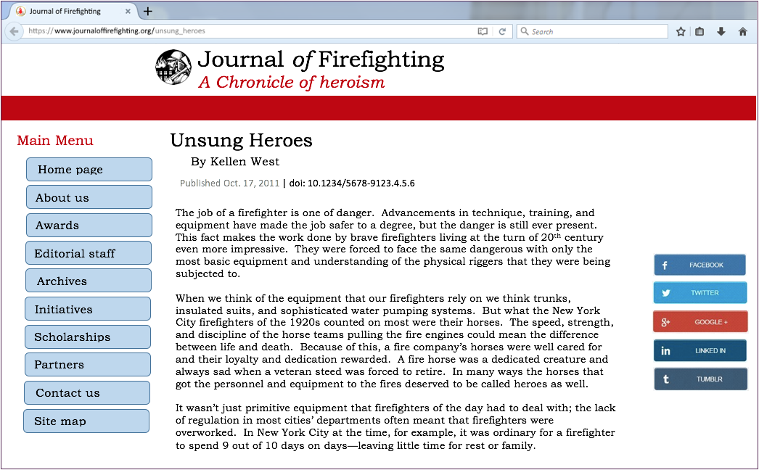

Article title

Author

Year of publication